APOSTILLE FORMALITY - PRACTICE

The rapporteurs are requested to verify and if necessary to supplement the information recorded for their Member State

- How can an Apostille be obtained?
- How is the authenticity verified (signature, the capacity in which the person signing the document has acted, and the identity of the seal or stamp which the document bears)?
- What is the form of the Apostille?
- How is the Apostille issued by the competent authority (placed on the public document itself or on a so-called ‘allonge’)?
- How is the Apostille issued when the public document consists of multiple pages?
- Which language is used on the Apostille?
- Is the system used for the issuance of an Apostille mechanical or electronic?
- What are the main measures taken in order to avoid fraud?
- Are there any plans to modernise the system used to issue Apostilles?
- How long does the total process generally take?
- What is the fee payable for the issuance of an Apostille? Who sets the fees? How is the level of the fees determined? Are they purely covering costs or can they also be said to be aimed at bringing revenue?

Member State | 1 | 2 | 3 | 4 | 5 | 6 | 7 | 8 | 9 | 10 | 11
Austria | In person or in writing |  | See Part 3 below |  |  | German |  |  |  |  | €16.20
Belgium | Request: in person or registered mail, mail, e-mail, fax, etc.  Obtainment: presentation of original document either in person or by mail (preferably registered mail) | Signature, capacity, identity of seal/stamp on document; card register used to verify signature | See Part 3 below | Either on document itself or on allonge, depending on size | Affixed on last page after signature | Dutch, French or German | Electronic | Control number on apostille linked with internet | No | In person: approx. 5 minutes  By mail: 10 days | €10  Fee set by the Minister of Foreign Affairs, Budget and Finance.  Determined by the tariff of the consular taxes: see, table 7 for relevant law  Currently aimed at bringing revenue but set to change.
Cyprus | In person or by mail | Authenticity of signature, capacity of signor, and identity of seal/stamp; signature specimens used | Pre-printed form attached as Schedule 2   | Placed on an allonge | Affixed in same place as signature | Language: English  Title: French | Mechanical | Manually-maintained register at Ministry of Justice and Public Order for verification | Yes: possible use of rubber stamps rather than pre-printed form | 3-4 minutes | CYP 2 (unless otherwise determined)  Fee set by Council of Ministers Order  Does not cover costs.
Czech Republic | In person or by (registered) mail | Signature cards; seal/stamp samples of all authorities of justice (inc notaries) | Label placed on document to be competed and signed; See Part 3 below | Placed on document itself, or on another attached sheet if no room | Placed at end of document under seal/stamp of issuing authority | Czech and English; Czech only if issued by Ministry of Foreign Affairs, Consular Dept | Mechanical | See point 2; also, special register of authenticated documents | Yes: taking part of E-Apostille Programme | In person: several minutes  Mail: several days | 100CZK  See Act No. 634/2004, the Administrative Fees Tariff  Income of state budget
Denmark | Na | Na | Na | Na | Na | Na | Na | Na | Na | Na | Na
Estonia | In person or by mail | Comparison of signatures and seals using catalogue of sample signatures | Corresponds to format in Convention | Attached to document | Bound together with remaining pages | English and Estonian (data only in English) | Electronic | Catalogue of samples; paper on which apostille is printed contains security elements and serial number | No | Usually issued same day as receipt, but at most 3 days | 120 Estonian kroons (€7.70)
Finland | In person or by (registered) mail | Most apostilles given to documents issued by other Finnish authorities and so no specific anti-fraud measures taken; if suspect, document will be revised |  | Allonge | Attached to document as last page and all pages will be sealed | Finnish and Swedish | Mechanical | See point 2 | No, but willing to participate in E-Apostille Programme if funded | 10-20 minutes | €9  Determined by Ministry of the Interior Decree (1065/2005)  Purely covers costs
France | In person or by mail |  | Large square referring to Hague Conention and giving the name of issuing authority | Placed on document itself | Placed on last page; occasionally a stamp and signature are added to every page if exceptionally long | French | Mechanical | In case of doubt, issuing institution will be contacted for verification; this is quite rare | No | 1-6 months | Free
Germany | In person or in writing (by mail) | Signature comparison to central register | See Part 3 below | Either on last side of document or additional attached sheet | Put on last page; all are attached and a seal is placed on all pages in the top corner OR the sheets will | German or English in some cases by request | Both | Seal is kept in a tresor; password protected if electronic method used | No; however in many Laender, there are plans to centralise the procedure | Written request: up to 2 weeks  In person: 5-20 minutes absent doubt; some, 2 days | €13-15  Many authorities differentiate between documents issued for private and business (higher fee) purposes  For documents issued by courts, Nr. 100 of the annex to sec. 2(1) JVKostO applies – fee depending on value of documented deal (€10-130)
Greece | 1. Judicial Documents and Notarial Acts: in person or through Citizen Service Centres (KEP)  2. Administrative Documents: in person, by mail or through a KEP | Verification of signature authenticity, capacity of signor and identity of seal/stamp done through sample book | Essential information such as name, contact details, authority, the request itself, the document, and the country of destination | 1.Allonge; Note: documents destined for Turkey use allonge in form of document consisting of large seal affixed in blue ink on an A4 page  2. 9.0 x 14.5 cm seal affixed in blue ink on certified document; allonge in exceptional cases | 1. Attached after last page  2. Affixed to last page | Printed entry fields in Greek and French with the fields in Greek | Neither as it consists largely of handwritten entries | None: reliability based on experience | No | 5-10 minutes; 10 days if through KEP | 1. €0.50  Not intended for profit  2. Free
Hungary | 1. Ministry of Justice: in person or by mail  2. Ministry of Foreign Affairs: in person | By using templates of the signatures and stamps of the respective authorities and persons | See Part 3 below | Issued on a separate sheet and afterwards stapled together | Issued on a separate sheet and afterwards stapled together | Hungarian, French | Electronic | By using templates of the signatures and stamps of the respective authorities and persons | No | 1. in person: immediately; by mail: a few days  2. Apostille is ready for the next day after the request, but in the case of persons arriving out of Budapest, the Apostille is ready on that day if the request is submitted before 10am | 1. HUF 2000 in stamp duty (about €7)  2. HUF 5,500 in cash (about €19)
Ireland | In person or by mail | Competent authority checks signatures, stamps and copies of their headed note paper against its registers of such signatures and stamps | The authority stamps the Apostille onto the document, fills out the details by hand (the notary’s name, the registration number, date etc.), then signs it and affixes the stamp of the Department | On document | Stamp for each page | English | Mechanical | See point 2 | No, but some plans for software re: notary precedents | In person: minutes  By mail: depends on postal system | €20 usually unless bundle of documents, where max fee is €50; fee for certificates of export is €10  Set by Minister of Foreign Affairs  Level determined having regard to fees levied by other contracting states  Fees do not cover cost of administering service and are not aimed at bringing in revenue
Italy
Latvia | In person or by authorised person | Verification of signature and stamp by comparison to examples electronically stored in catalogue within system of electronic registration system of document legalisation | See Part 3 below | On document itself or if no space, annexed as Alonge | Document must be sewn and sealed together | English | Electronic | See point 2; additionally, competent authorities have power to request verification from issuing authorities | Yes: E-Apostille | 10 days | 1. Physical persons – 5 LVL  2. Urgent legalisation (within 48hr, not including holidays) – 10LVL  3. Authorized person, that is not relative or spouse of authorizer – 10LVL  4. Urgent legalisation (within 48hr, not including holidays) – 20LVL.  5. Legal persons – 10LVL  6. Urgent legalisation (withing 48hr, not including holidays)- 20LVL  7. Senior citizens and politically repressed persons (showing documentation) – 1,5LVL  8. Urgent legalisation (within 48hr, not including holidays) – 3LVL.  Set by Cabinet of Ministers Nr. 254 from June 25,2002
Lithuania
Luxembourg | In person or by mail | Verification of authenticity of signature or identity of seal or stamp by comparison to originals previously made available to the passport office | Stamp and signature of official of passport office; see Schedule III [[can’t find Schedule III]] | On document; allonge if no space on document | Last page of document | French | Mechanical | No specific measures taken | Will become electronic in the future; first, stamps will be replaced by self-adhesive label | Issue in 2 days; total process 4 days | €1  Fees set by Grand-ducal decree
Malta | In person | Database of all signatories used for comparison | 1. the name of the country, 2. the name of the person signing the document, 3. the capacity of the person signing the document, 4. the seal/stamp of the same person, 5. The place where the Apostille is done i.e. at the Ministry of Foreign Affairs, 6. the date, 7. the name of he legalisation officer, 8. the number of the Apostille, 9. the Seal/stamp and 10. the Signature. | On document | Same page as signature to be legalised | English | Electronic | See point 2. | No | 5 minutes | Lm 7 (€17) for general documents; Lm 5 (€12) for University certificates and Public Registry documents  Fee set by the Government  Aimed at bringing in revenue
Netherlands | By (registered) mail or in person | Paper files kept of all signatures for comparison | Either a word document or mechanical print from with text from annex to Treaty along with official seal and stamp | Both methods used depending on available space | Placed on page with signature | Dutch, German, French, Spanish, or Italian depending on type of document and group requesting apostille | See point 3 | Unique number and official court seal; signature comparison | No | 10 minutes | €16  Set in the Law on Tariffs for Civil Cases  Covers costs only
Poland
Portugal
Slovak Republic | In person or by registered letter | Specimen signatures and stamps used, as well as lists of those with capacity | Label or rubber stamp; See Part 3 below | On document where signature is located; if no space, then an allonge is attached by way of a tricolour small round seal and signature | Same | Drawn up in Slovak and translated into English; title and Convention in French | Mechanic | Apostille labels and stamps are registered in “The Book of Legalisation” and they are numerated | No, but would participate in E-Apostille program with funding | In person: same day  By mail: 10 days | 200 crowns  Set by Ministry of Finance of the Slovak Republic under item 3, sub paragraph c which is an annex to Act No. 145/1995  Fee overlays costs and represents revenue
Slovenia | In person or by (registered) mail | Verification of signature, capacity, and seal/stamp by comparison to authority’s lists of signatures, people, and stamps and seals used; if unsure, will contact signor | Modeled on form set out in Annex to Convention | On document’s last page if space; otherwise an allonge is used | Last page of document or if no space, on allonge attached at end of document; all pages then bound using official string, state stamp, and sticker | Slovene; title and Convention in French | Mechanical | Maintaining up-to-date files of names, signatures, and stamps of all with authority  Issuing the Apostille on document itself to prevent detachment and reattachment | No | In person at Ministry of Justice: same day; at District Court, the next day | Ministry of Justice: SIT 255 (€1)  Set in Law on Administrative Taxes  Covers costs  District Courts: between 570 and 1140 SIT (€2.37 to 4.76)  Set in Law on Court Taxes  Covers costs
Spain | In person or by (registered) mail | Verification of signature and capacity through a register containing signatures | Form laid down in Real Decreto 2433/1978 de 2 de Octubre; see Part 3 below | On document if enough space; otherwise on allonge | On end of last page if space; otherwise on allonge | Spanish | Use either a seal or print out of apostille on document or allonge | Apostille describes document to which it is attached; security stamp placed on it by issuing authorities | No | 2-3 days; urgent requests can be same day | Secretaries of the Regional High Courts and Head of the Central Section of the Subsecretary of the Ministry of Justice: free  President of the Association of Public Notaries: €3.94
Sweden | In person of my mail | Notaries are usually familiar with issuing officials; if uncertain, will check against registers of officials and authorities, or demand copies of signatures or stamps | Stamp or printout; copies are enclosed with the completed questionnaire | On document after signature if enough space; otherwise on an allonge | Same, plus pages will be threaded together (but this is not regulated) | Text in English or another foreign language spoken by the Notary Public in question | Mechanical | Presenting fraudulent document is punishable by law; otherwise, see point 2 | No, however, the single Notary Public has wide discretion to organise practical administration of system | One day | Approx 12 Swedish crowns or €32  Government ordinance SFS 1982:327 sec. 12:  Fees aimed at bringing some revenue
UK | In person, by mail, courier, or document exchange | Legalisation Office checks signatures and seals against samples held on its electronic database. | They’ve included a PDF sample:   | Allonge glued securely to document; embossed seal of Secretary of State is affixed so that its impression is apparent both on the apostille and the doc itself | Apostille affixed on page bearing signature, seal or stamp authenticated (or on reverse side) | English and French | Information completed electronically; apostille affixed manually | Seal is embossed and apostille is printed on watermarked paper; each apostille has unique number stored in secure computer database; if doubt as to authenticity, proper enquiries are made and police alerted if evidence of fraud | Existing hardware and software is updated and replaced as necessary; open to review of systems if E-Apostille system implemented internationally | In person: same day  By mail: within 10 working days  Document exchange: completed by end of following day | £19.00  Fee fixed by Order-in-Council which is then laid before Parliament: Consular Fees Order 2005 (S.I.2005/1965)  Intended to recover costs only

- the number of authorities
- their identity and contact details
- the name and contact details of an approachable contact person at the competent authority(ies).

PART 3: Form of Apostille
Austria | Apostille  (Convention de La Hayed u 5 octobre 1961)  1. Land ………………………………………………………………………………….  Pays  Diese öffentliche Urkunde / Le present document official  2. ist unterzeichnet von ………………………………………………………………...  a été signé par  3. in seiner Eigenschaft als …………………………………………………………….  agissant en qualité de  4. Ist versehen mit dem Siegel/Stempel des (der) …………………………………..  la sceau/timbre qui y figure est celue de  Bestätigt / Ainsi fait  5. in …………………………. 6. am ……………………  à (lieu) le (date)  7. durch ……………………… 8. unter Zl.  par (autorité d’attestation) sous Nº …… du registre  9. Siegel/Stempel ………….. 10. Unterschrift ……………  Sceau ou timbre Signature
Belgium | “Apostille (Convention of the Hague 5 October 1961) 1. Country: Belgium 2. This public document has been signed by… 3. acting in the capacity of… 4. bears the seal/stamp of… Certified 5. at… 6. the… 7. by the Federal Public Service Foreign Affairs 8. N° … 9. Seal/stamp… 10. Signature…
Czech Republic | Issued by the Ministry of Justice  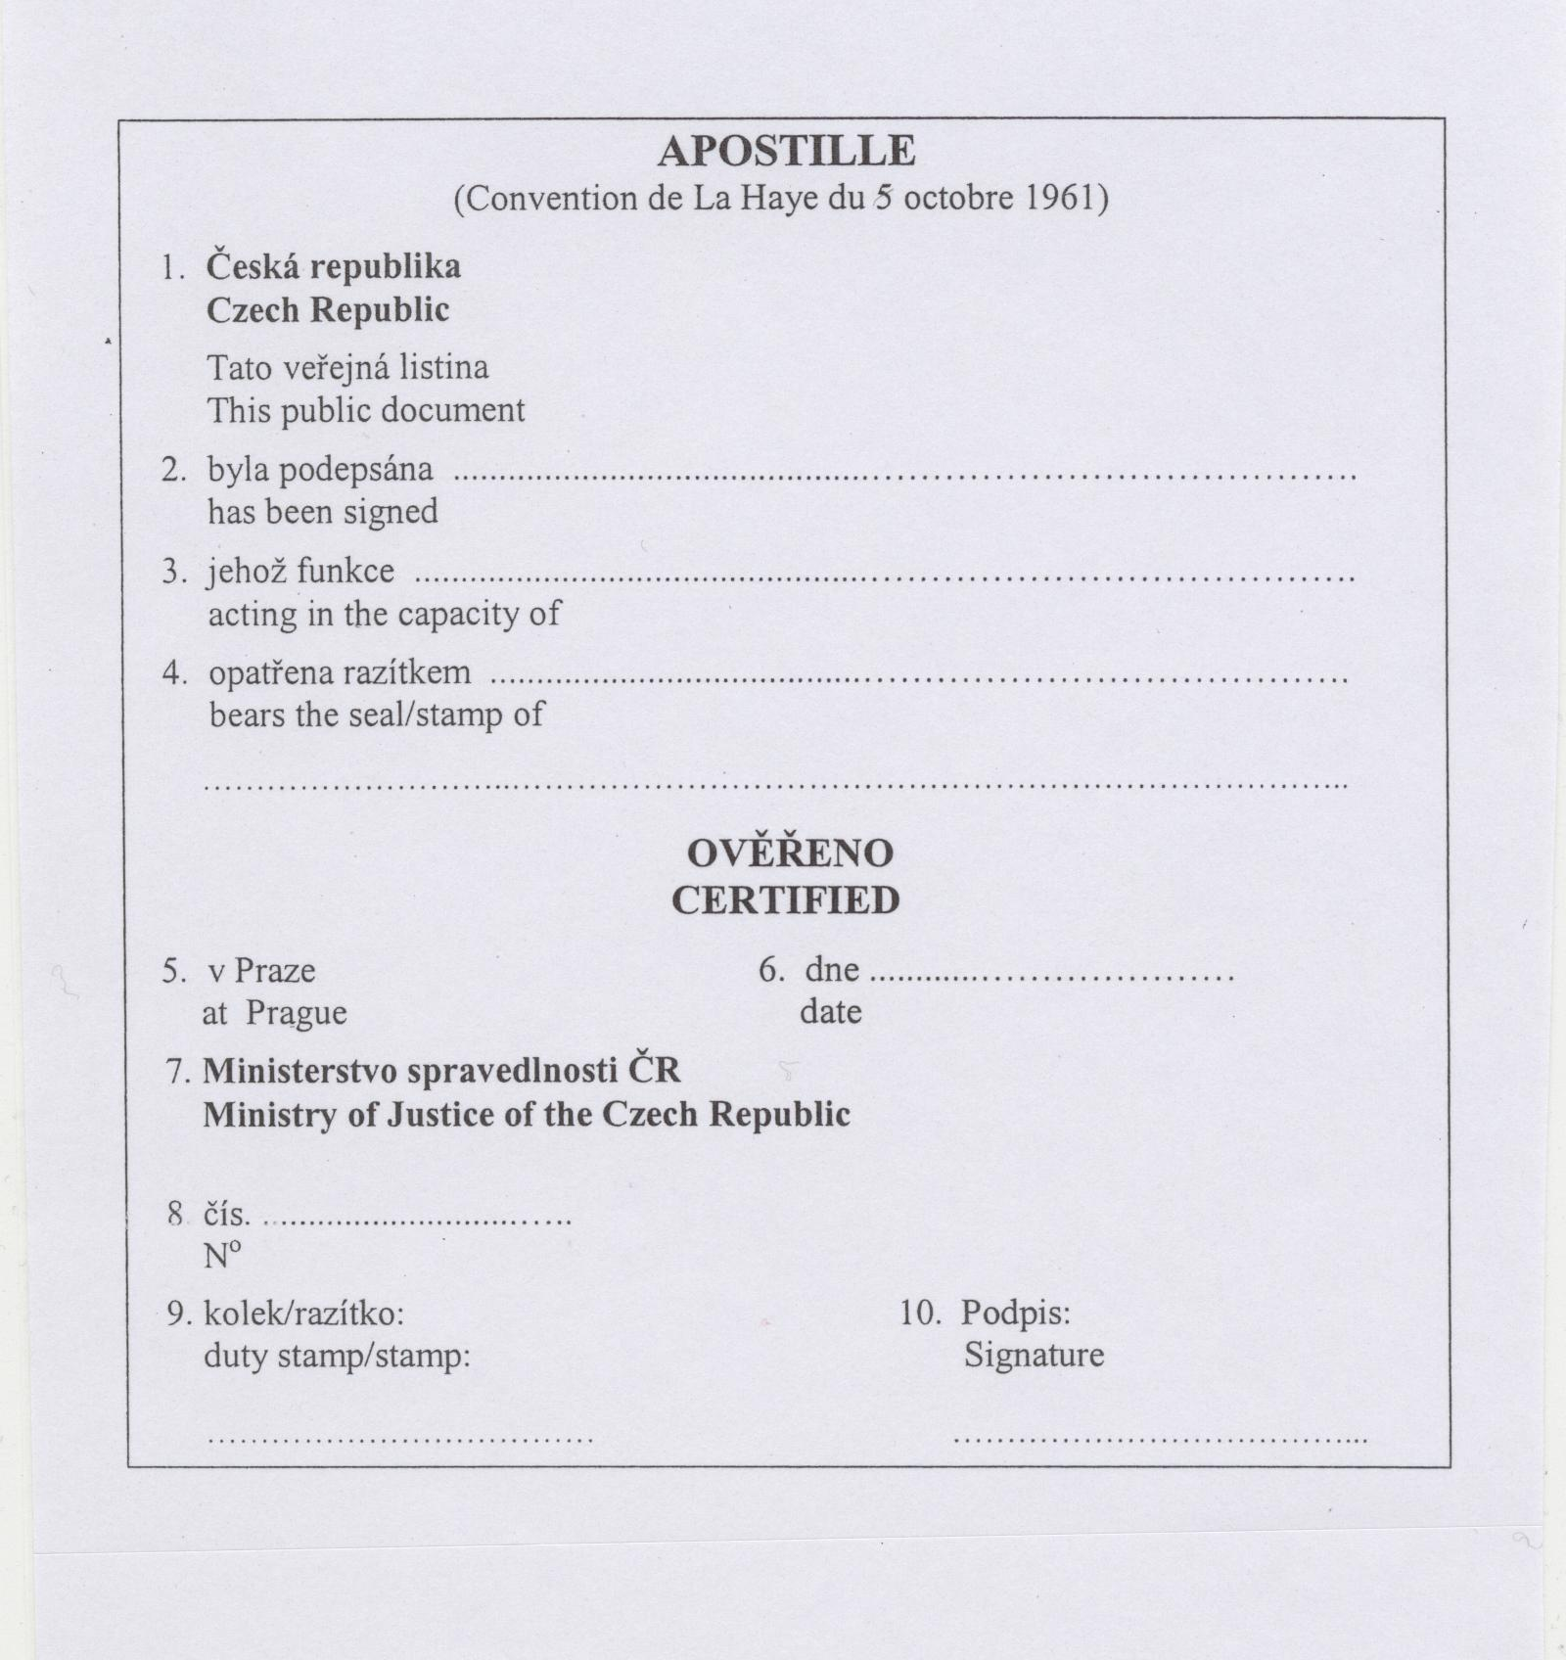  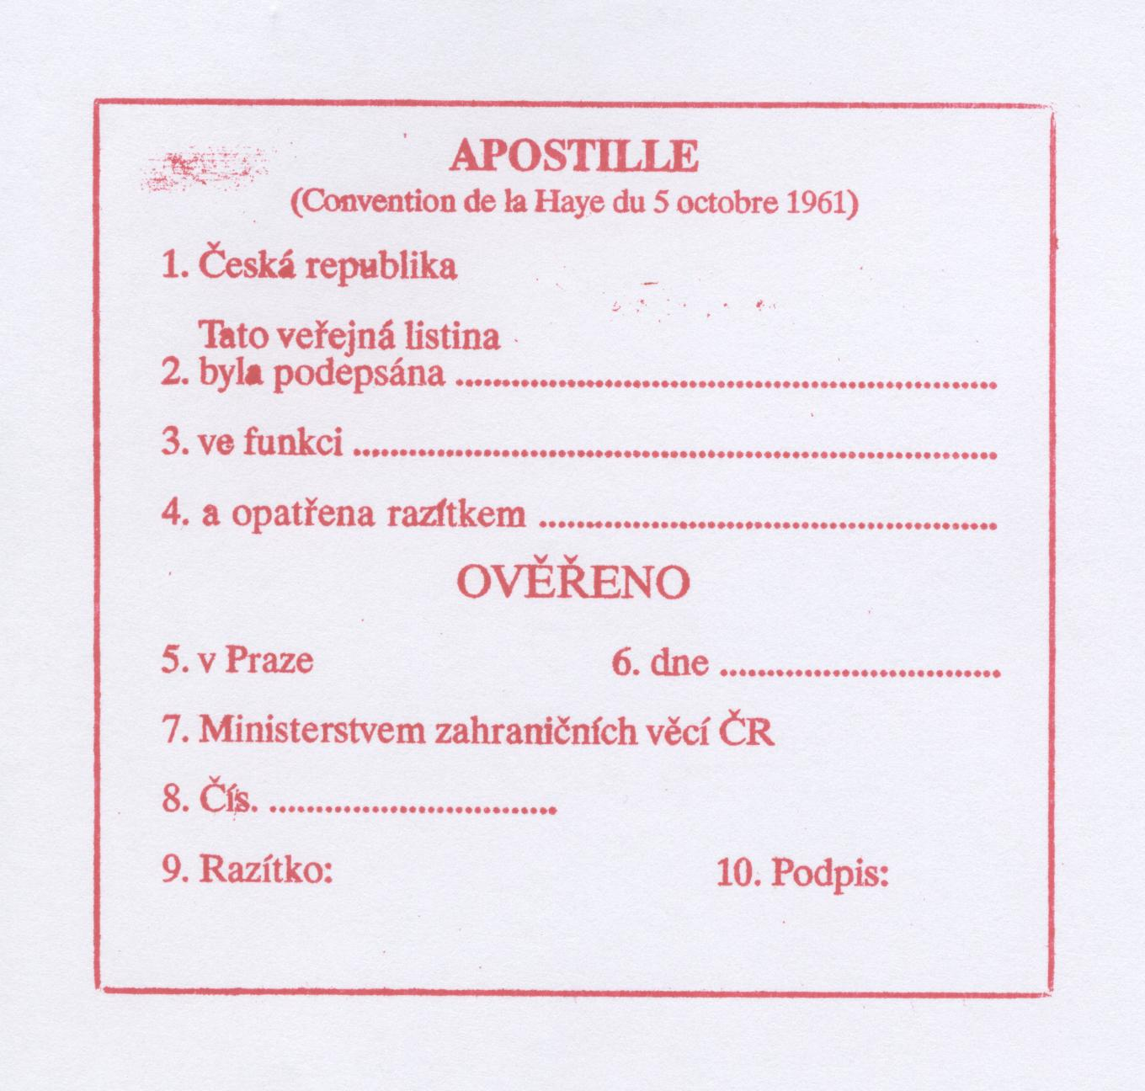  Issued by the Ministry of Foreign Affairs of the Czech Republic  Translation:  - Czech Republic  - This public document was signed  - In function  - And furnished by the stamp of CERTIFIED  - In Prague  - On  - By the Ministry of Foreign Affairs of the Czech Republic  - No.  - Stamp:  - Signature
Germany | APOSTILLE  (Convention de La Haye du 5 octobre 1961)  1. Land: ………..  Diese öffentliche Urkunde  2. ist unterschrieben von ………….  3. in seiner Eigenschaft als ……………  4. sie ist versehen mit dem Siegel/Stempel des (der) ……….  Bestätigt  5 in ……….. 6. am ………..  7. durch ………..  8. unter Nr. ……………  9. Siegel/Stempel 10. Unterschrift
Hungary
  APOSTILLE
  (Convention de la Haye du 5 octobre 1961)
  Ország.........................................................................................
  Pays:
  Ezt a közokiratot
  Le présent acte public
  a été signé par: .............................................................................
  írta alá
  agissant en qualité de: ..................................................................
  minőségben eljárva
  Az okirat ......................................................................................
  est revętu du
  sceau/timbre de ............................................................................
  pecsétjével (bélyegzőlenyomatával) van ellátva
  Tanúsítja
  Attesté
  ŕ: ..................................................................................................
  Időpont: ........................................................................................
  Kiállító: ........................................................................................
  Par:
  Ügyszám: .....................................................................................
  Sous N°:
  Pecsét (bélyegzőlenyomat):
  Sceau/timbre:
  10. | Aláírás:
   | Signature:
  ...............................................................
Latvia | 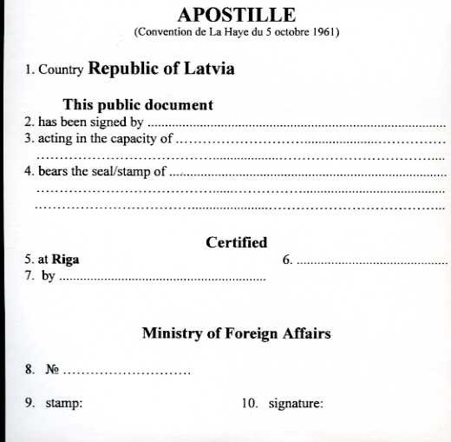
Slovak Republic | 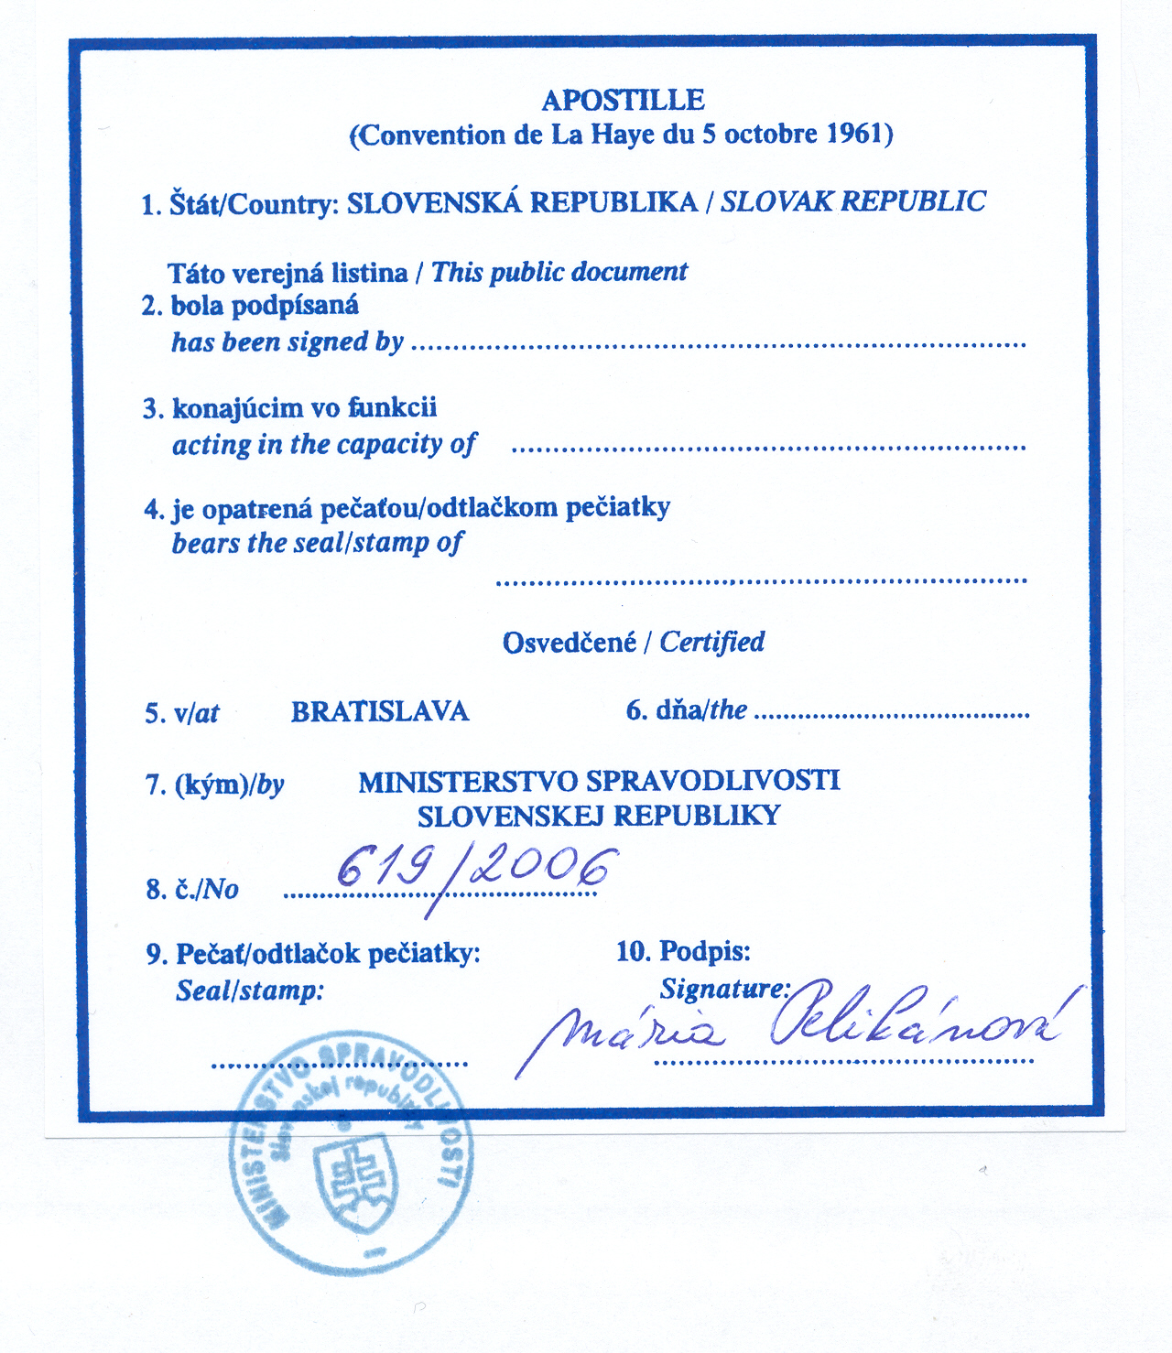
Spain | Translation in English
  Apostille (or unique legalisation)
  (Convention de La Haye du 5 octobre, 1961-Real Decreto 2433/1978 de 2 de octubre)
  - Country: Spain---------------------------------------------------------------------------------
  This Public Document------------------------------------------------------------------------
  - has been signed by-------------------------------------------------------------------------------------------------------------------------------------------------------------------------------
  - acting in capacity of Notary Public--------------------------------------------------------
  - bears the seal / stamp of the Notary’s offices of-----------------------------------------
  Certified
  - At BARCELONA……………………….. 6. The 6 June of 2006.--------------------
  - By Mr. RAFAEL MARTINEZ DÍE, Secretary of the Board of Directors of the Association of Notary Public of Catalonia------------------------------------------------
  - With the Number: -35206/2006------------------------------------------------------------
  - Seal/stamp: 10 signature
  Rafael Martínez Díe
  Secretary

