Regional Research Project „Development of collective redress for consumers in South East Europe”

Strengthening the regional cooperation in the field of collective redress for consumers in South East Europe is the central focus of a running project funded by the German Ministry of Economic Cooperation and Development and implemented by Deutsche Gesellschaft für Internationale Zusammenarbeit (GIZ), Open Regional Fund for South East Europe-Legal reform. This will be achieved by carrying out a comparative legal analysis on “Collective redress mechanisms in light of the European Commission Recommendation (2013/396/EU) on common principles for injunctive and compensatory collective redress mechanisms emphasizing cross-national comparisons, underlining issues of commonality and difference” aiming to detect the existing deficits and different obstacles for an adequate enforcement of collective redress according to the consumer protection laws in South East European (SEE) countries and to develop relevant suggestions for the improvement of the situation. The study will present the legislative and institutional framework and legal practice on collective redress with an emphasis on damages claims in selected EU member states (Belgium, France, Germany, the Netherlands, Sweden and England / Wales) and SEE countries. The Study’s recommendations and conclusions will provide the responsible institutions and organisations with solid basis for exchange, which will entail the development of a Regional Action Plan to strengthen capacities for implementing collective redress and handling collective claims, preparation and delivery of three training modules and implementation of a regional awareness campaign on collective redress to improve services of the Consumer protection organisations members of the Consumer Organisations Network South East Europe (CONWEB).
The project was launched on 1st of January 2017 in duration of 22 months. The key regional project partners are the Consumer Organizations Network South East Europe (ConWeb) and South East European Law School Network (SEELS) and the key international partner is the British Institute of International and Comparative Law (BIICL).

The project is supported by:

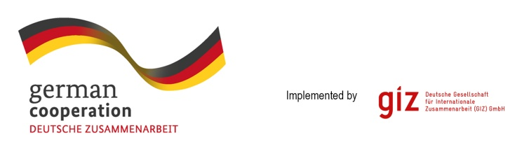

http://conweb.network/
http://www.seelawschool.org/
https://www.biicl.org/

